SIMATS ENGINEERING (SAVEETHA SCHOOL OF ENGINEERING)
Department of Computer Science and Engineering
CO1 ASSESSMENT TOOL 1 – Case Study Analysis
Course Code: | CSA10 / CSA1004 | Course Title: | Software Engineering
CO Assessed: | CO1 | Assessment: | Assessment Tool 1 – Case Study Analysis
Weightage: | 20% | Total Marks: | 25
Student Name: | Pradhap J | Reg. No.: | 1924260246
Date: | 09-10-2026 | Duration: | 60 minutes

Code of Conduct
I Pradhap J / 1924260246 (Name / Reg No) certify that this submission is my original work and that I have adhered to the guidelines specified for this assessment. I understand that any violation of academic integrity rules will result in disciplinary action.
Signature of the Student: 

Annexure A – Case Study Analysis
Problem Statement 34: Intelligent Personal Finance Management System
1. Understanding the Problem Statement
Problem in my own words. Most individuals find it hard to know where their money goes. Daily expenses, recurring payments such as rent, subscriptions and EMIs, savings and financial goals are tracked in memory, notebooks or scattered apps. Manual tracking is tedious, transactions are not organized into categories, and it gives no meaningful insight into spending behavior. People overspend, miss payments and fall short of their savings goals. A system is needed that records transactions, organizes them automatically, and guides the user with budgets, alerts and personalized recommendations.
Objectives of the proposed system
- Record income and expenses and categorize transactions automatically.
- Track recurring payments and upcoming bills.
- Create and monitor budgets by category.
- Monitor savings goals and show progress toward them.
- Analyze spending patterns and generate financial alerts.
- Provide financial summaries and personalized budgeting recommendations.
Scope
In scope: a web and mobile application for individual users covering transaction entry and import, automatic categorization, recurring payments, budgets, goals, spending analysis, alerts, summaries and reports. Out of scope: actual payment processing or fund transfers, investment trading, tax filing, and loan or credit approval.
2. Key Stakeholders and Challenges
Stakeholder | Roles and responsibilities | Key challenges
Individual User (primary) | Records or imports transactions, sets budgets and goals, acts on insights | Forgets to log expenses, no clear picture of spending, overspending
Family Members / Co-users | Share household budgets and goals | Unclear shared expenses, no common view
System Administrator | Manages users, categories, rules, system health and security | Protecting sensitive data, handling errors and misuse
Banks / Payment Providers (external) | Supply transaction data through statements, SMS or APIs | Varying data formats, limited access, privacy rules
Financial Advisor (optional) | Reviews summaries and guides the user | Needs accurate, organized data
Developers and Support Team | Build, maintain and support the system | Changing requirements, accuracy of categorization

Major challenges: difficulty tracking daily expenses, forgotten recurring payments, no spending insight, unplanned expenditure, unrealistic or no budgets, slow progress on savings goals, wrongly categorized transactions, and privacy of financial data.
3. Analysis of the Current Approach
Existing process. Individuals note expenses in notebooks, spreadsheets or memory, check bank statements and messages occasionally, and keep reminders for bills on a calendar or phone. Budgets, if any, are rough monthly estimates and goals are tracked mentally.
Strengths | Limitations
Simple and familiar  Free, with no new tools to learn  Full manual control of data  Spreadsheets are flexible | Manual entry is time-consuming and often skipped  No automatic categorization  Recurring payments are missed  No spending analysis or trends  No alerts when the budget is exceeded  No personalized recommendations  Data is scattered and not secure

Gaps to be addressed: no unified record of all transactions; no automatic categorization; no recurring payment tracking; no budget monitoring and alerts; no goal tracking; and no insight-driven recommendations.
4. Proposed Solution Using Software Engineering Principles
Solution design. A layered web and mobile application. Users add transactions manually or import them from statements (CSV/PDF) or bank APIs. A categorization engine assigns each transaction a category using merchant keywords and user-defined rules, improved by a machine learning classifier (for example Naive Bayes or logistic regression on transaction text) that learns from user corrections. An analytics module computes spending trends and budget usage, and a recommendation module suggests budget limits and savings actions. The stack is a React/Flutter front end, a Node.js or Spring Boot REST backend with JWT authentication, a PostgreSQL database, and a scheduler for reminders and alerts.
Major functional modules
Module | Description
User and Account Management | Registration, login, profile, linked accounts and wallets
Transaction Management | Add, edit, import income and expenses; search and filter
Smart Categorization | Automatic category assignment, user rules and corrections
Recurring Payment Tracker | Detect and schedule recurring bills, subscriptions and EMIs
Budget Management | Set category budgets, track usage, compare with actual spending
Savings Goal Management | Create goals, target amount and date, track progress
Analytics and Recommendations | Spending patterns, trends and personalized budgeting suggestions
Alerts and Summaries | Budget, bill-due and goal alerts; weekly and monthly summaries; PDF reports

Functional requirements
- Secure registration and login.
- Record, import, edit and delete income and expense transactions.
- Automatically categorize transactions and allow user correction.
- Track recurring payments and send due-date reminders.
- Create budgets and alert the user when limits are near or exceeded.
- Create savings goals and show progress.
- Display spending analysis, summaries and personalized recommendations.
Non-functional requirements
- Performance: screens load within 3 seconds; categorization in under 1 second per transaction.
- Availability: at least 99% uptime.
- Security: encrypted data at rest and in transit, strong authentication, privacy protection.
- Usability: simple, responsive interface with clear charts.
- Scalability: supports thousands of users and years of transaction history.
Software engineering principles applied
Principle | How it is incorporated
Modularity | Separate modules (transactions, categorization, budgets, goals, analytics) with defined APIs; the categorization model can be upgraded independently
Scalability | Stateless services, database indexing, caching of summaries, cloud deployment
Maintainability | Clean code, documentation, Git version control, automated tests, configurable rules
Reliability | Input validation, duplicate detection on imports, backups, error handling
Usability | Dashboard with charts, quick-add entry, clear alerts, minimal steps
Security | Password hashing, JWT, HTTPS, field-level encryption of financial data, audit logs, privacy controls

5. Justification of the Chosen Methodology: Agile (Scrum)
Selected framework: Agile using Scrum, with two-week sprints, a product backlog, sprint reviews and retrospectives.
Why it is suitable
- User needs and insight features are best discovered through early feedback; Scrum accepts changing requirements.
- Modules can be delivered incrementally: Sprint 1 login and transactions; Sprint 2 categorization and recurring payments; Sprint 3 budgets and goals; Sprint 4 analytics, recommendations, alerts and reports.
- A usable expense tracker is available early, so users can try it and the categorization can be improved with real data.
- Waterfall is too rigid for a data-driven product that must be tuned, and Spiral adds more risk-analysis overhead than needed.
Support for development and maintenance
- Sprint reviews with users keep features practical.
- Continuous integration and testing protect financial calculations.
- The recommendation and categorization models can be improved in later sprints.
- After release, fixes and new features (new banks, new report types) are added as backlog items.
6. Expected Outcomes and Limitations
Expected benefits
- Improved expense visibility in one place.
- Better budgeting and reduced unnecessary expenditure.
- Increased savings awareness and faster progress toward goals.
- Better financial planning through summaries and trends.
- Personalized financial insights.
How the solution addresses the challenges
Challenge | Solution
Manual, forgotten expense tracking | Quick entry, import and automatic categorization
Missed recurring payments | Recurring tracker with due-date reminders
Overspending | Category budgets with threshold alerts
Slow savings progress | Goal tracking and suggested savings amounts
No spending insight | Analytics, summaries and recommendations

Risks and limitations
- Privacy and security of sensitive financial data is the biggest risk.
- Categorization may be wrong at first, especially for unusual merchants.
- Depends on users entering or importing data regularly; bank API access may be limited.
- Recommendations are guidance only and are not professional financial advice.
Future enhancements
- Receipt scanning with OCR and voice entry.
- Predictive forecasting of future expenses and cash flow.
- Investment and credit score insights; bill payment integration.
- Shared family budgets and a conversational assistant.
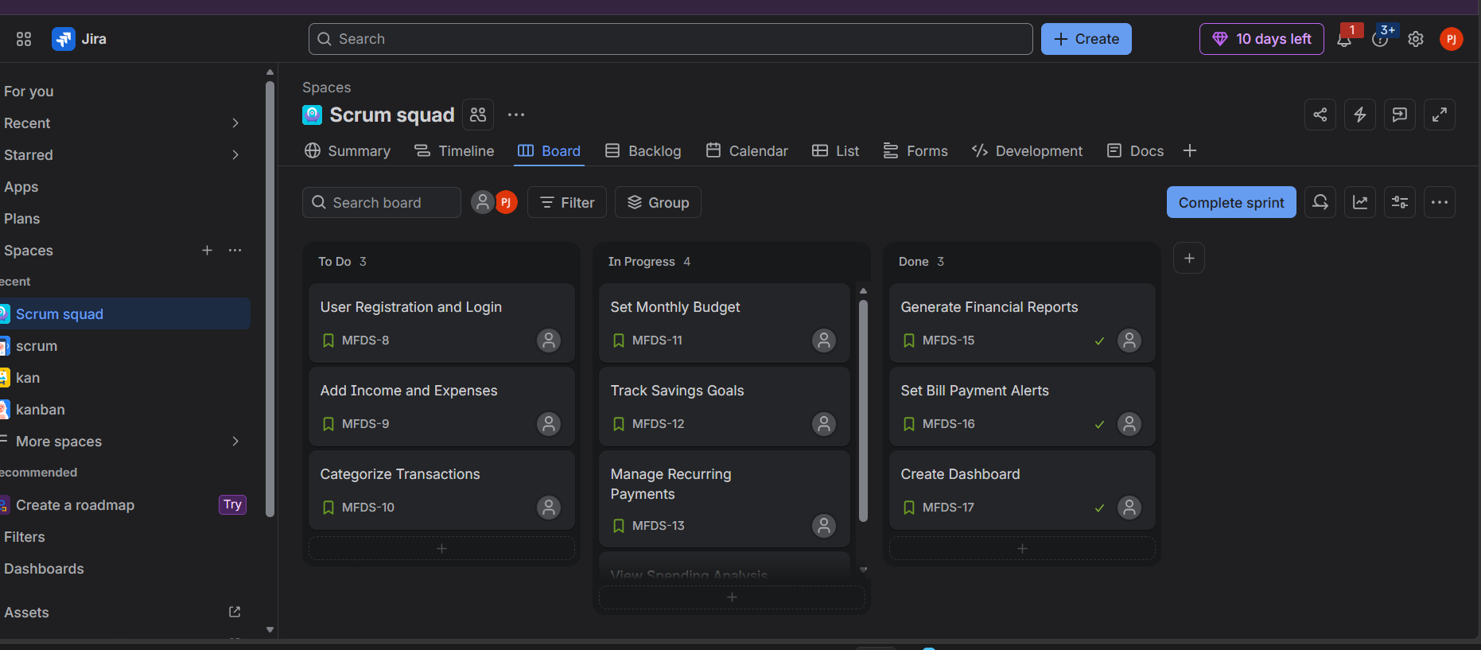
Figure 1: Scrum board (Jira) of the project, showing sprint backlog items in To Do, In Progress and Done.

